RESOLUTION NO.__________

RE: CERTIFICATE OF APPROPRIATENESS UNDER THE
PROVISIONS OF THE ACT OF THE PENNSYLVANIA
LEGISLATURE 1961, JUNE 13, P.L. 282 (53
SECTION 8004) AND BETHLEHEM ORDINANCE NO.
3952 AS AMENDED.

WHEREAS, it is proposed to repair masonry on west façade and repaint with a new sign at 301 Broadway.

NOW, THEREFORE, BE IT RESOLVED by the Council of the City of Bethlehem that a Certificate of Appropriateness is hereby granted for the work.

Sponsored by: (s)

(s)

ADOPTED BY COUNCIL THIS DAY OF

(s)
President of Council

ATTEST:

(s)
City Clerk

HISTORIC CONSERVATION COMMISSION

CASE # 595– It is proposed to repair masonry on west façade and repaint with a new sign at 301 Broadway
OWNER/APPLICANT: Sycamore Hill Farm Development/ Larry Eighmy

The Commission upon motion by Mr. Evans seconded by Mr. Lousch adopted the proposal that City Council issue a Certificate of Appropriateness for the proposed work described herein:
- The proposal to repair masonry on west façade and repaint with a new sign at 301 Broadway was represented by Larry Eighmy.
- The sign will read “SOUTHside” in black or other dark neutral color.
- The masonry work on the building will be as proposed and defined below
- The Southwest façade repair as follows:
  - Remove approximately 16” of the top of the brick SW facing façade (previously approved)
  - Replace existing concrete capstones with copper clad coping
  - Repair SW brick façade with stainless steel helical ties to wall areas adjacent to the sides of the Wells Fargo sign (1 anchor per 2 SF)
  - Repoint upper portion of the façade with Type N mortar
  - Wash entire SW façade wall and repaint with elastomeric coating, color to be decided
  - Paint new SOUTHside sign on edge of façade in black

- West Stair Tower parapets repairs as follows:
  - Rebuild approximately 3’ of the top parapet
  - Rebuild approximately 2’ of the lower parapet
  - Replace concrete capstones with copper clad coping

- Terra Cotta Cornice above upper cornice repairs as follows:
  - Replace existing deteriorated sealants with appropriate backer rod and new sealant on top of parapet
  - Repoint all defective mortar joints of parapet
  - Repair/patch spalled terra cotta with special repair mortar specifically for terra cotta manufactured by Conproco, Inc.

- The brick used for the repairs must match the historic brick in size, texture, and color as closely as possible.

- Drawings showing flashing details must be submitted to the City for review and approval.

- The motion to approve the proposal was unanimously approved.

CU: cu
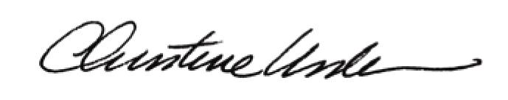

By:

Date of Meeting: September 19, 2016 Title: Historic Officer

